Before he became an international movie star, albeit a computer generated one, [Groot](http://en.wikipedia.org/wiki/Groot), the ‘man-tree’ Guardian of the Galaxy had a much more sordid and humble past and a strange, unintended connection, with body building.

Groot was introduced to comic book fans by Stan Lee, Jack Kirby and Dick Ayers in a 7-page story entitled [“I Challenged…Groot! The Monster from Planet X!”,](http://www.comics.org/issue/15942/#126848) which first appeared in Tales to Astonish #13 (not Astonishing Tales as stated in Wikipedia) published in 1960.

The basics outline of the story is simple. Our lead character, Leslie, a bookish scientist, is driving with his wife, Alice, late one night. Alice, none too impressed with her selection of a man, pines for a more rugged specimen.

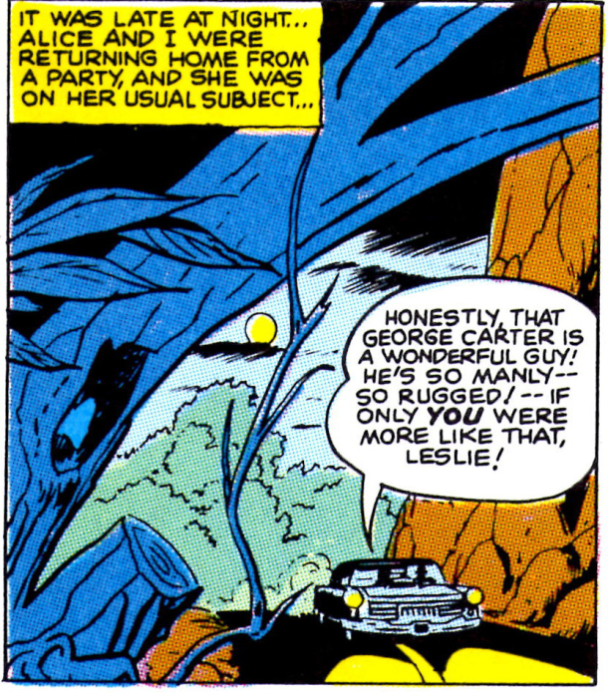

On their way, they both witness a strange object lighting up the forest as it lands but Alice demands to be taken home rather than allow Leslie to investigate. Driven by curiosity, Leslie decides to return to the forest but not before Alice gets in a dig about his softness as a man for driving rather than walking.

Out in the forest, Leslie soon discovers the source of the light. Groot, the Monarch from Planet X, has landed on Earth. Groot intends to kidnap the residents of the nearby town for immediate transportation back to his world and subsequent experimentation.

Blockades are setup and the town’s men gather to repel Groot’s assualt.

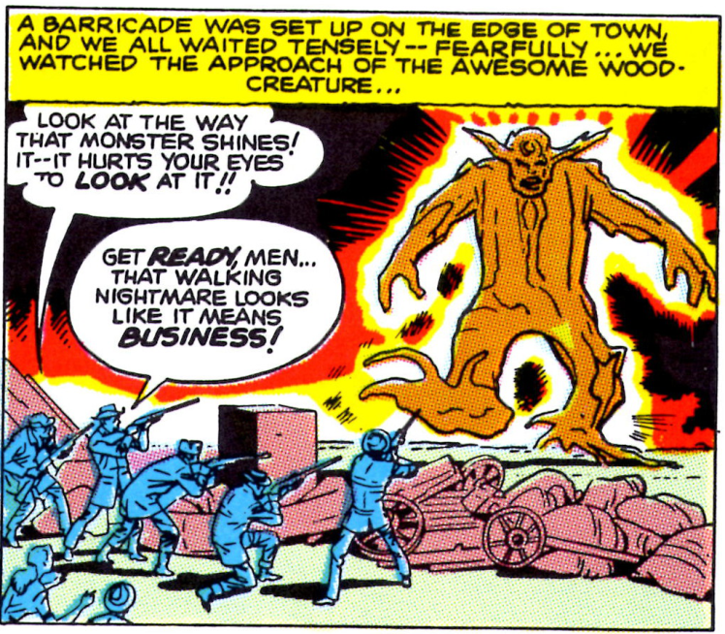

Groot’s wooden hide proves to powerful and he moves in to claim the town. At that moment, Leslie issues a challenge that he will stop Groot before the town falls. Leslie immediately runs from the skirmish, which earns him even more scorn, this time from Groot who calls him a coward.

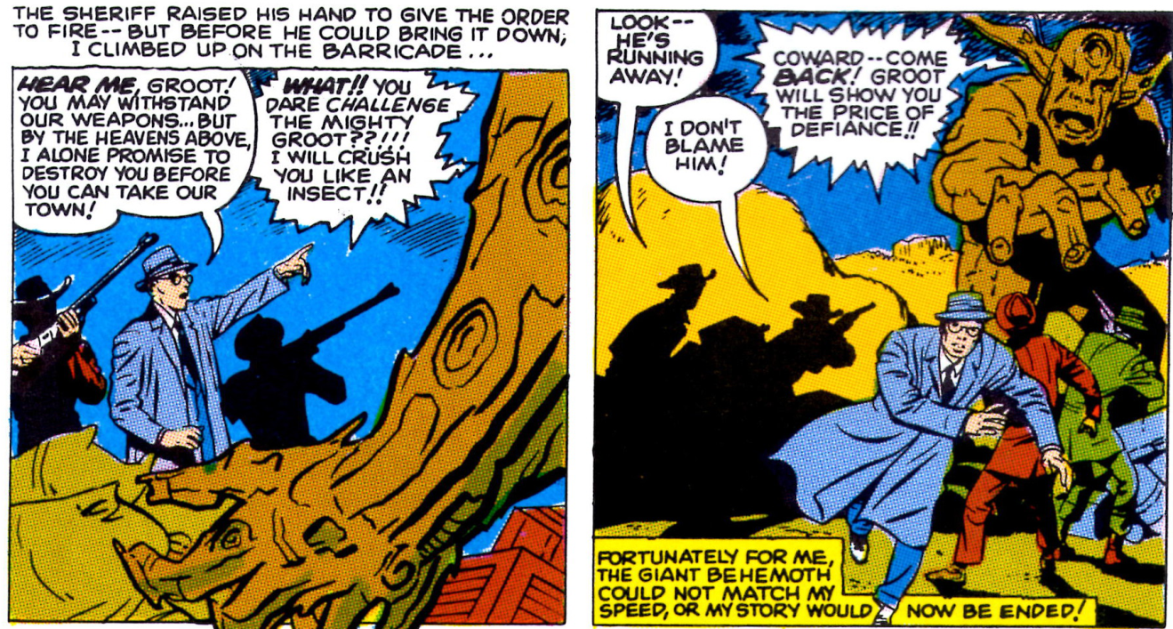

We soon find Leslie in his lab working feverishly to stop Groot, while the alien’s tree servents close in around the town. As usual, Alice is not very supportive.

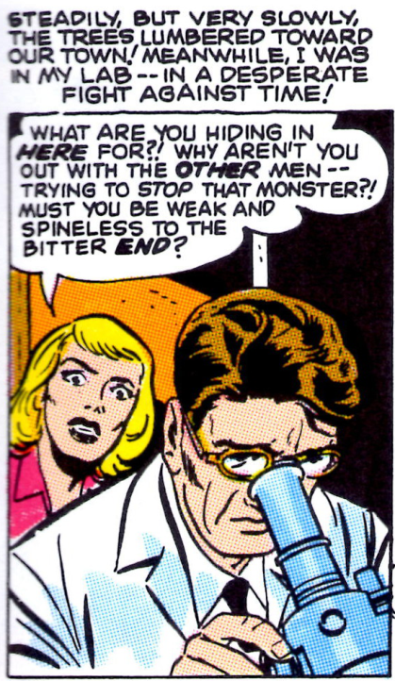

The bitter end does come quickly but for Groot, as the special termites that Leslie engineered in his lab make short work of the ‘menace from outer space’. We are left with a parting shot where the Sheriff is dumbfounded at Leslie’s cleverness while Alice embraces her hero.

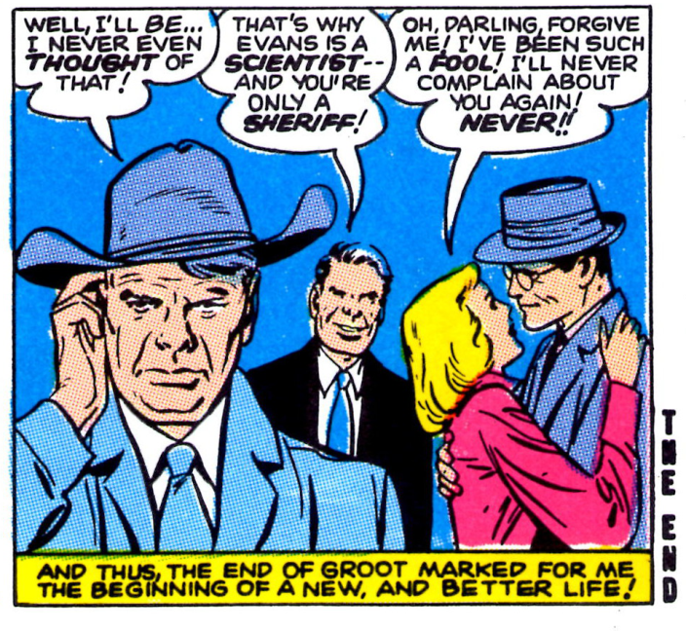

I admit a feeling of déjà vu when I first read this story in Monster Masterworks sometime in the early nineties but I was never able to identify its root. Like so many of the little mysteries in life, the answer revealed itself at a time of its own choosing.

The revelation began when I returned from the Guardians of the Galaxy movie and pulled this story out to review. It suddenly hit me that it was structured very similarly to an old body building advertisement that used to run in the seventies.

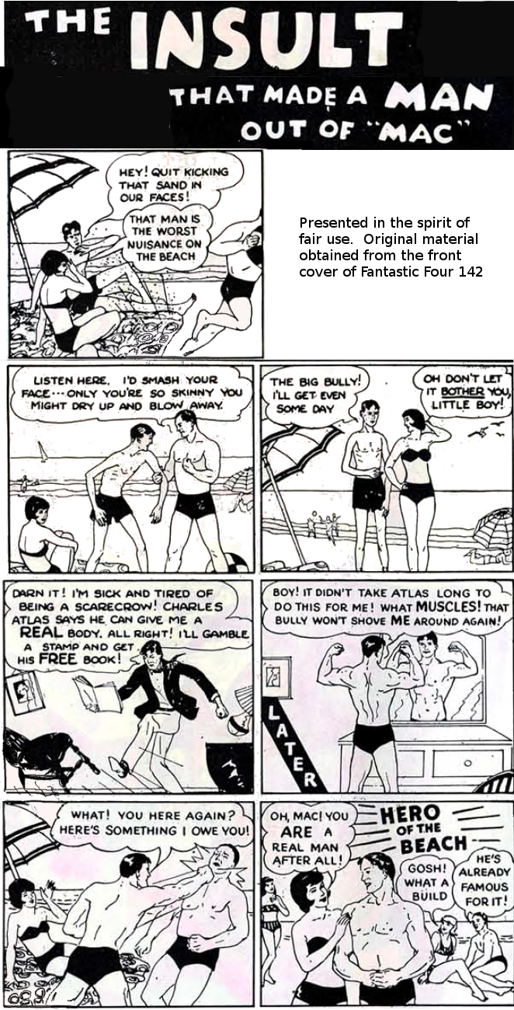

Notice the similarities? Of course, the Groot story predates this ad by at least a decade and I don’t think that one influenced the other. It is more likely the case that this is an archetypical story about a man proving himself worthy of a woman.

And before we pat ourselves on the back and congratulate ourselves for moving beyond such shallowness, I’d point out that that while the form this story takes changes with time the essential core remains the same. If you don’t believe me, watch Ghostbusters again for an example from the eighties.